***Chemistry***

**10: Liquids and Solids**

**10.2: Properties of Liquids**

23. Although steel is denser than water, a steel needle or paper clip placed carefully lengthwise on the surface of still water can be made to float. Explain at a molecular level how this is possible:

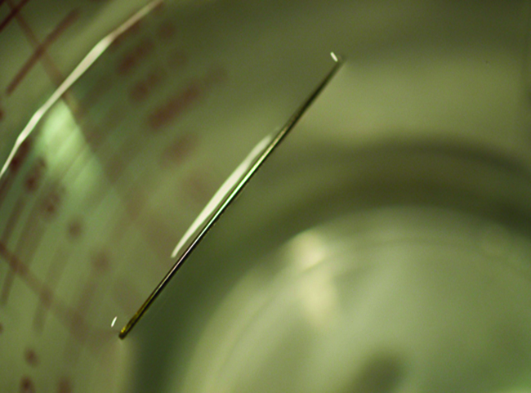

(credit: Cory Zanker)

Solution

The water molecules have strong intermolecular forces of hydrogen bonding. The water molecules are thus attracted strongly to one another and exhibit a relatively large surface tension, forming a type of “skin” at its surface. This skin can support a bug or paper clip if gently placed on the water.

25. You may have heard someone use the figure of speech “slower than molasses in winter” to describe a process that occurs slowly. Explain why this is an apt idiom, using concepts of molecular size and shape, molecular interactions, and the effect of changing temperature.

Solution

Temperature has an effect on intermolecular forces: the higher the temperature, the greater the kinetic energies of the molecules and the greater the extent to which their intermolecular forces are overcome, and so the more fluid (less viscous) the liquid; the lower the temperature, the lesser the intermolecular forces are overcome, and so the less viscous the liquid.

27. The surface tension and viscosity of water at several different temperatures are given in this table.

|  |  |  |
| --- | --- | --- |
| Water | Surface Tension (mN/m) | Viscosity (mPa s) |
| 0 °C | 75.6 | 1.79 |
| 20 °C | 72.8 | 1.00 |
| 60 °C | 66.2 | 0.47 |
| 100 °C | 58.9 | 0.28 |

(a) As temperature increases, what happens to the surface tension of water? Explain why this occurs, in terms of molecular interactions and the effect of changing temperature.

(b) As temperature increases, what happens to the viscosity of water? Explain why this occurs, in terms of molecular interactions and the effect of changing temperature.

Solution

(a) As the water reaches higher temperatures, the increased kinetic energies of its molecules are more effective in overcoming hydrogen bonding, and so its surface tension decreases. Surface tension and intermolecular forces are directly related. (b) The same trend in viscosity is seen as in surface tension, and for the same reason.

29. Water rises in a glass capillary tube to a height of 17 cm. What is the diameter of the capillary tube?

Solution

This time we will solve for *r*, as we are given h = 17 cm = 0.17 m.



This resource file is copyright 2015, Rice University. All Rights Reserved.